Favorite Math Problem
Problem: George and Phil were playing with their fish tank again. They had a difficult time keeping their fish alive. The fish tank is 100cm long, 60 cm wide and 40 cm high. They tilted the tank, as shown, resting on a 60 cm edge, with the water level reaching the midpoint of the base. When they rest the tank down to a horizontal position, what is the depth of the water in cm? (9th grade math problem)
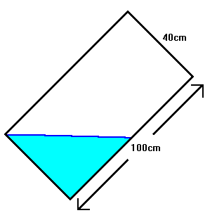
ANSWER:
Volume of the water =

Volume of 1/2 of tank = 1/2 100cm * 40cm * 60cm
= 120,000

1/2 (120,000) = 60,000

60,000 = 100 cm * 60 cm * d
10 cm = d

