Amanda Horvers
Favorite Math Problem-Problem Solving
Help from: http://www.mystfx.ca/special/mathproblems/
George and Phil were playing with their fish tank again. They had a difficult time keeping their fish alive. The fish tank is 100cm long, 60 cm wide and 40 cm high. They tilted the tank, as shown, resting on a 60 cm edge, with the water level reaching the midpoint of the base. When they rest the tank down to a horizontal position, what is the depth of the water in cm? (9th grade math problem)
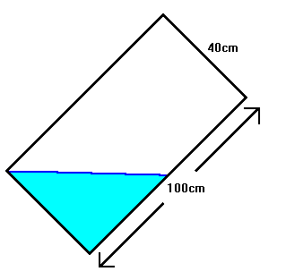

Show Work Below

