Amanda Horvers May 8th, 2012
Hands-On-Activity: Grade level 6th
Topic: Ratio, Proportion, and Volume
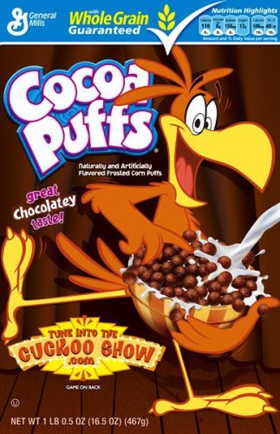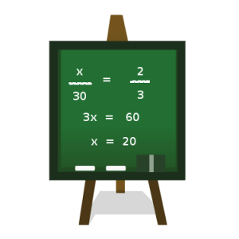
Basic overview for this activity
For this activity the students will…
Be asked to complete a hands-on activity during the length of one class period. The task will be to bring in his/her favorite cereal (in the box please!). I will ask the students to try and purchase cereal that would be easy to count out by hand. The boxes that I will specify on purchasing are the INDIVIDUAL SIZE boxes, NOT the family size larger boxes of cereal. I will be supplying the larger boxes myself for the students.
Once the cereal boxes are brought in the task will be to count out the number of cereal pieces in the individual size boxes on either a paper plate or paper towel on his/her desk. Then the students will find the volume for that box by using the ruler given and correctly measuring the box. The students’ will do the same for the volume of the larger box of cereal in order to fill out the worksheet. Once this task is complete the students will be asked to create a proportion and find the value of “X” (the estimated number of cereal pieces in the larger box).
I. Title for this activity: Ku Ku for Cocoa Puffs
II. Materials needed to complete this activity include
- Worksheet with instructions
- Ruler for each student
- Paper towel, paper plate, bowls and spoons
- Pencils/erasers
- Small (individual) cereal boxes and large (family size) cereal boxes
III. Goals for Activity
1) Students will learn and understand the concept of the terms ratio, proportion, and volume.
2) Students will learn how to find the volume of both boxes of cereal and properly compute and make their own ratios and proportions using the knowledge they already know about the topic.
Objectives for Activity
1) Given the hands-on activity worksheet, the student will complete the activity “Ku Ku for Cocoa Puffs” with 80% or better accuracy based on a 20 point rubric. (See attachment)
2) Given the proper materials the student will measure and determine the volume of each of his/her cereal boxes (cm^3) to create a proportion set up with 100% accuracy.
3) Given the three vocabulary terms from this hands-on activity, the student will be able to define each term with 100% accuracy.
IV. Vocabulary Terms
- Ratio- is just a comparison between two different things. A:B
- Proportion- a part considered in relation to the whole. The relationship between things or parts of things with respect to quantity. 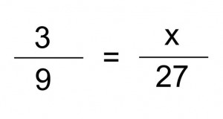 or A/B=X/C “find X”
- Volume- is the amount of space that a three dimensional object can occupy.
Volume of a rectangle- V= (L*W*H)^3

STEPS FOR COMPLETING THIS HANDS-ON ACTIVITY
- Gather all materials need for this activity. (materials shown on activity worksheet)
- Carefully open your small box of cereal and pour it on a paper plate or towel. In two trials count the number of cereal pieces. Place the numbers in the chart given.
- The next step is to measure the sides of the individual box in centimeters and calculate the volume (cm^3).
- In the spaces provided use the numbers found in step two and three to create a ratio.
- Finally, use the following knowledge found above to determine how much cereal could be in the larger box!?( Create a proportion)
- Hand in activity fully completed! Must be neat and organized!
- EAT UP!!!

Hands-on activity worksheet by Amanda Horvers
Name_________________________________________________ Date___________________
Directions:
Below is a hands-on activity where you will be asked to calculate the volume (cm^3) of your individual cereal box and count by hand the amount of cereal pieces in the box. Once you have completed these first couple of tasks you will then create a ratio using the information gathered from the small individual cereal box. You job is to determine or give an estimation of how many pieces of cereal you have in the larger cereal box?
Before you begin gather your Materials:
- Ruler for each student
- Paper towel, paper plate, bowl and spoon
- Pencils/erasers-any writing utensil but activity must be legible!!!
- Small (individual) cereal boxes and large (family size) cereal boxes
Work area:
Here are the steps for completing this activity
1) For this section using only the individual box of cereal that you have brought into class, count the number of cereal pieces in the box. Please count the amount TWICE to be accurate! (Use either the paper plate/bowl/towel to spread out cereal in a neat fashion)
Trial count (1): Trial count (2):
Number of
Cereal
Pieces

2) Next, measure the sides of the same cereal box in centimeters and calculate the volume (cm^3)

3) Next: CREATE A RATIO USING THE INDIVIDUAL CEREAL BOX CALCULATIONS AND MEASUREMENTS…remember to label!!

4) Finally: using the larger box of cereal make a prediction about how many pieces of cereal could be in that box knowing the knowledge you already have about the small cereal box…(proportion?)

Math - Problem Solving : Ku Ku for Cocoa Puffs

Teacher Name: Ms. Horvers
Student Name: ________________________________________

CATEGORY | 5 | 4 | 3-2 | 1
Mathematical Concepts | Explanation shows complete understanding of the mathematical concepts used to solve the problem(s). | Explanation shows substantial understanding of the mathematical concepts used to solve the problem(s). | Explanation shows some understanding of the mathematical concepts needed to solve the problem(s). | Explanation shows very limited understanding of the underlying concepts needed to solve the problem(s) OR is not written.
Strategy/Procedures | Typically, uses an efficient and effective strategy to solve the problem(s). | Typically, uses an effective strategy to solve the problem(s). | Sometimes uses an effective strategy to solve problems, but does not do it consistently. | Rarely uses an effective strategy to solve problems.
Completion | All problems are completed and given in the correct form | All problems but one or two parts are completed. Proportions need some work. | Answers to problems are not fully complete and missing values for proportions. | Several of the problems are not completed. No proportions shown
Neatness and Organization | The work is presented in a neat, clear, organized fashion that is easy to read. | The work is presented in a neat and organized fashion that is usually easy to read. | The work is presented in an organized fashion but may be hard to read at times. | The work appears sloppy and unorganized. It is hard to know what information goes together.

RubiStar |  | Rubric Made Using:  RubiStar ( http://rubistar.4teachers.org )  .

